**DAILY ONLINE ACTIVITIES SUMMARY**

|  |  |  |  |
| --- | --- | --- | --- |
| **Date:** | 23/05/2020 | **Name:** | Krishnitha |
| **Sem & Sec** | 4th sem, A Section | **USN:** | 4AL18CS039 |
| **Online Test Summary** | | | |
| **Subject** | Data Communication | | |
| **Max. Marks** | 30 | **Score** | 27 |
| **Certification Course Summary** | | | |
| **Course** | STEPathon-communication skills [ICT ACEDAMY] | | |
| **Certificate Provider** | THE HINDU | **Duration:** | 2hrs. |
| **Coding Challenges** | | | |
| **Problem Statement:**  Write a C Program to generate first N Triangular Numbers (Where N is Read from the Key board) | | | |
| **Status:** Executed | | | |
| **Uploaded the report in GitHub** | | YES | |
| **If yes Repository name** | | <https://github.com/krishnitha/C-coding/blob/master/TriangularNumbers.c> | |
| **Uploaded the report in slack** | | YES | |

Online Test Details:

Today we had assessment in the subject Data Communication. It was based on first module of this subject. There were total 30 number of questions of 1 mark each.

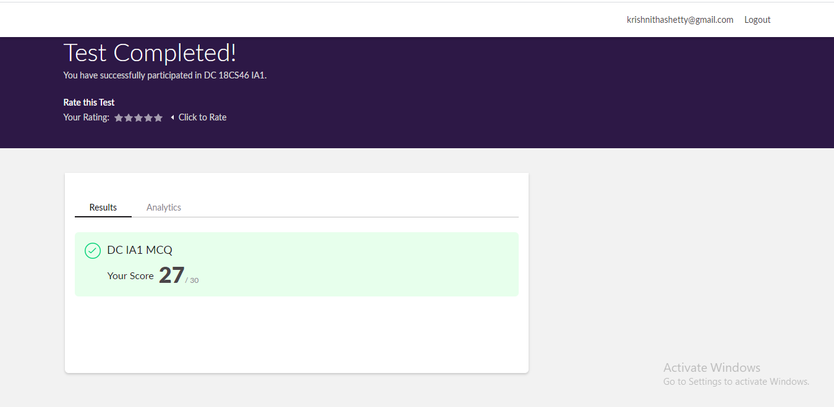

Certification Course Details:

I have done certification course on communication skills i.e., “THE STEPathon9” by The Hindu group. This course has a series of video-based webisodes or lessons which form an exciting story about a group of friends as they take a trip across India. Each webisode focuses on various language skills like reading, writing, listening, speaking, grammar, vocabulary

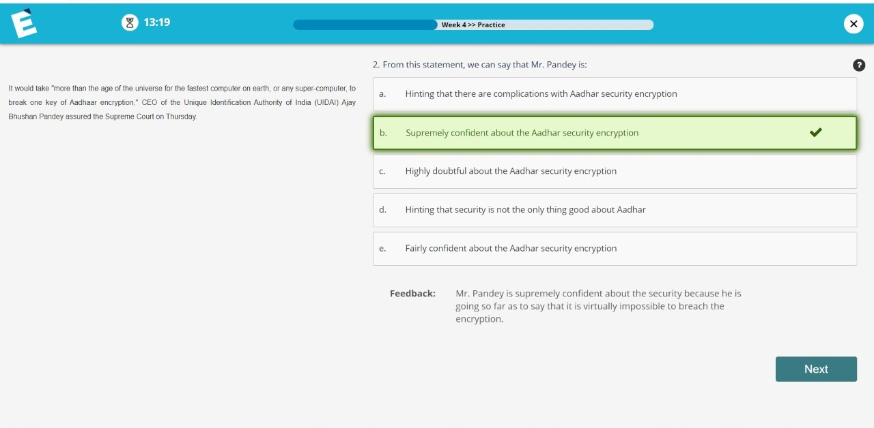

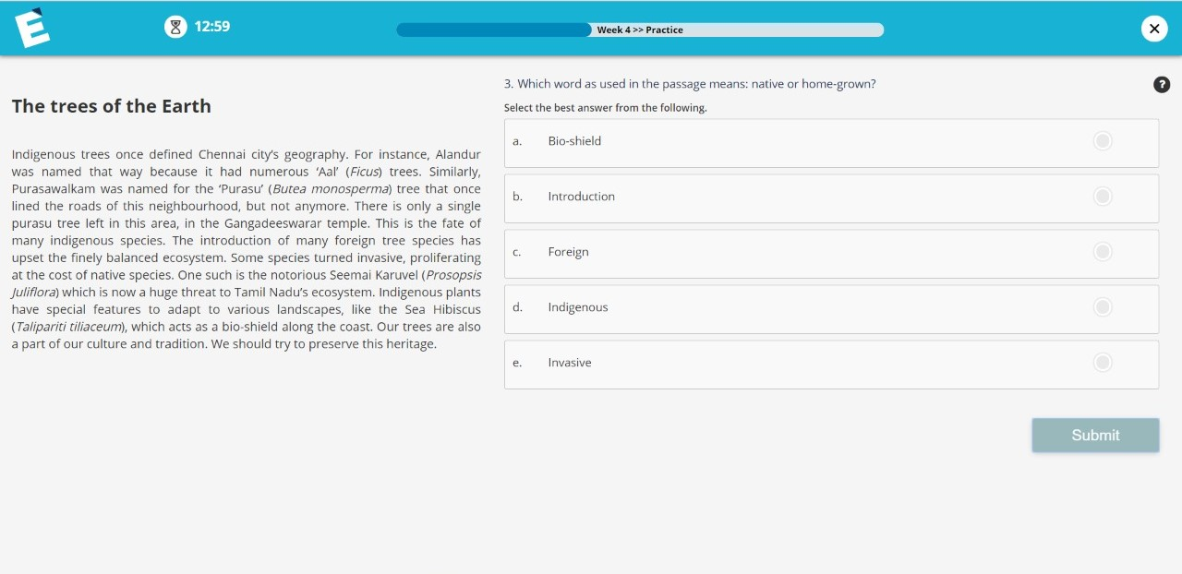

Coding Challenges Details:

Problem 1: Write a C Program to generate first N Triangular Numbers (Where N is Read from the Key board)

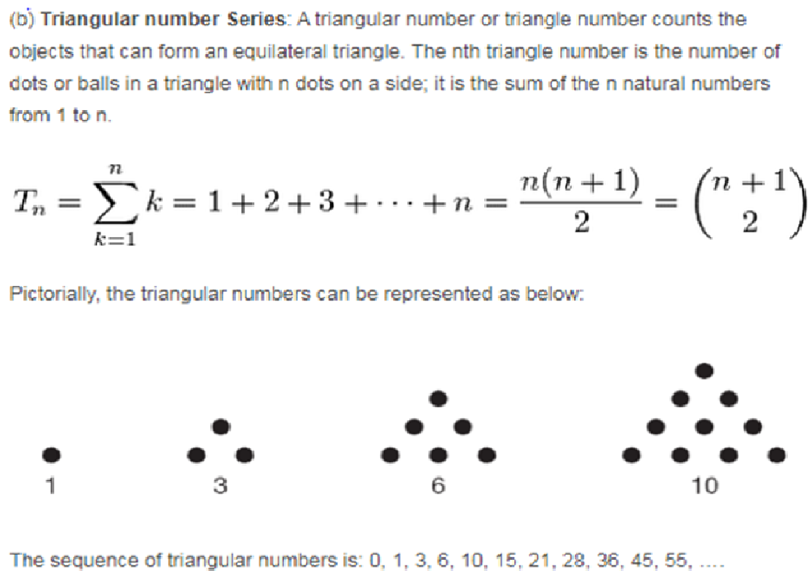

**Solution:** Uploaded it in GitHub

